**Using Home ECG Monitor as a 12-LEAD EKG Machine**

During the cardiac cycle, an electric signal starts from the top left sinoatrial (SA) node, travels to the center of the heart (atrioventricular) and then to the lower chamber. The signal causes the upper heart chambers to expand and fill with blood, passes the blood to the lower chambers, which will then pump the blood out to the body. The expand and contract action of both heart chambers are controlled by the electric signal. An ECG machine captures and displays the signal. The ECG waveform can reveal a lot about the health of the heart, such as irregular rhythm and damaged heart muscle.

Since the electric signal is 4-dimensional (including time) and each pair of electrodes can only capture the signal at one particular angle. To get a complete picture, a complete ECG machine uses 10 electrodes to capture 12 leads or signals at different angles.

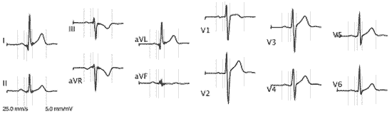

A home EKG machine, such as [MD100A12](http://www.healthcare4home.com/personal-ecg-monitor-md100a12/p.html), can only capture one signal at a time; however you can still obtain the 12-lead signals by taking measurements one at a time and positioning the electrodes accordingly.

**Electrode placements for 12-LEAD signals**

Limb electrodes can be placed anywhere on the limb provided they are at least 4 inches from the heart.

For MD100A12, the cable labeled LA is positive, RA is negative and LL is ground.

RA - Right arm  
LA - Left arm  
RL - Right leg  
LL - Left leg

|  |  |  |  |
| --- | --- | --- | --- |
| **LEAD** | **RED** | **YELLOW** | **GREEN** |
| **I** | RA | LA | RL |
| **II** | RA | LL | RL |
| **III** | LA | LL | RL |
| **aVR** | LA/LL1 | RA | RL |
| **aVL** | RA/LL1 | LA | RL |
| **aVF** | RA/LA1 | LL | RL |
| **V1** | RL | v1 | LL |
| **V2** | RL | v2 | LL |
| **V3** | RL | v3 | LL |
| **V4** | RL | v4 | LL |
| **V5** | RL | v5 | LL |
| **V6** | RL | v6 | LL |

1 Put an electrode at each location and connect them via another cable.

